Name: L Hill Class: Nursery Week Beg: 17.1.22
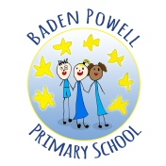
School Closure Home Learning Task Sheet: Expectations – 1 Maths Task + 1 Literacy Task Each Day and 1 Topic Task per week.
This task overview sheet is designed to be used by parents and pupils in the event of a school closure.
Tasks and activities do not need to be completed in the order that they are written.
Visit the school website and your child’s class page to view this sheet and any hyperlinks electronically.
Maths Skill: Number   | Literacy Skill: Oracy  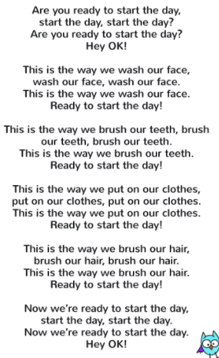  Activity: Use singing to encourage your child to talk about their daily routines. Talk about all the things you do to get ready in the morning.  Then try it at bedtime…
  Activity: Let’s learn all about the Number 1. Together explore your house.
  Say aloud each time they spot one item.
  Indicate with one finger.
  For example, 1 TV, 1 chair, 1 doll
Maths Skill: Number formation rhyme  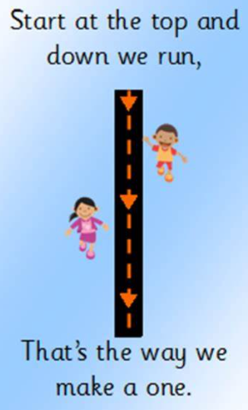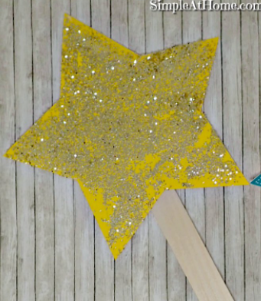  Here is a rhyme to help remember the way to write number one.  Use your finger and write in the sky. Remember to stretch up high.  Make the star you made last week into your Number Wand to draw Number 1 in the air. | Literacy Skill:  Activity: Reading  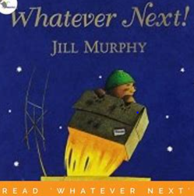  Remember to share a story each day.  By revisiting their favourite stories it builds memory and confidence.
Maths Skill: Number Formation  Activity: Practice writing the number one.  Always start at the top of the number. Find fun ways to write it.  e.g. condensation on the window, shaving foam on bathroom tiles, or just simply with crayons on paper. (you can use Gloop, too!)  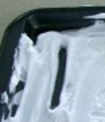 | Literacy Skill: Letters and Sounds  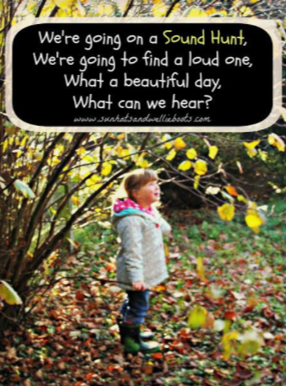  Activity: In readiness for learning letters sounds, children have to be able to listen to, hear and distinguish what sounds are around them. Do they hear different sounds at different times of the day? Try going on a Sound Walk…
Maths Skill: Measures  Activity: Find a small container e.g. aerosol can lid, yoghurt pot. Encourage your child to find as many things to put in. What things will not fit? Why? Use words such as small/little, big/large  Can they sort what fitted and what did not?  It may look like this…  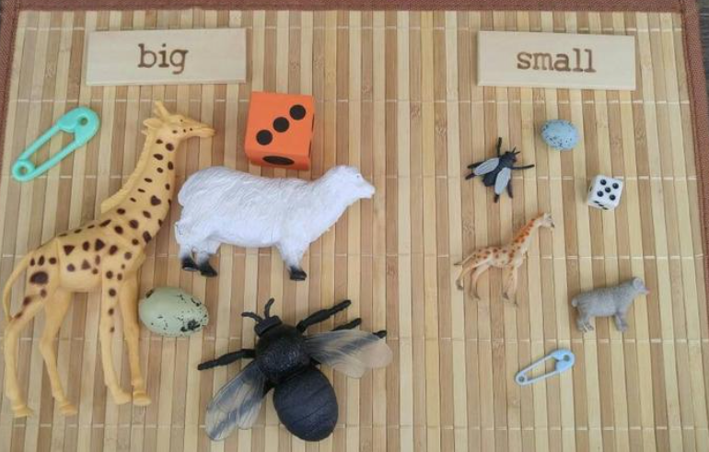 | Literacy Skill: Mark-making and writing  Activity:  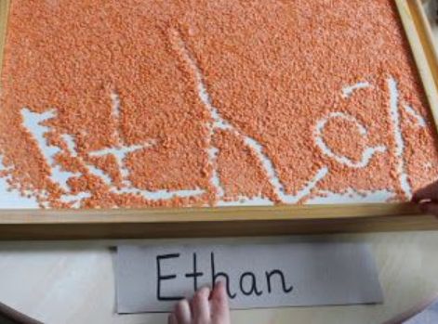  Encourage your child to make marks, patterns and letters in dry foods e.g. flour, lentils, rice placed in a shallow tray or lid. When they’re done, give it a shake and make something new.
Maths Skill: Counting  Activity: Saying and singing, counting and number songs are so important for childrens understanding of number. There are plenty of counting songs and rhymes available. Search Youtube for some lovely examples.  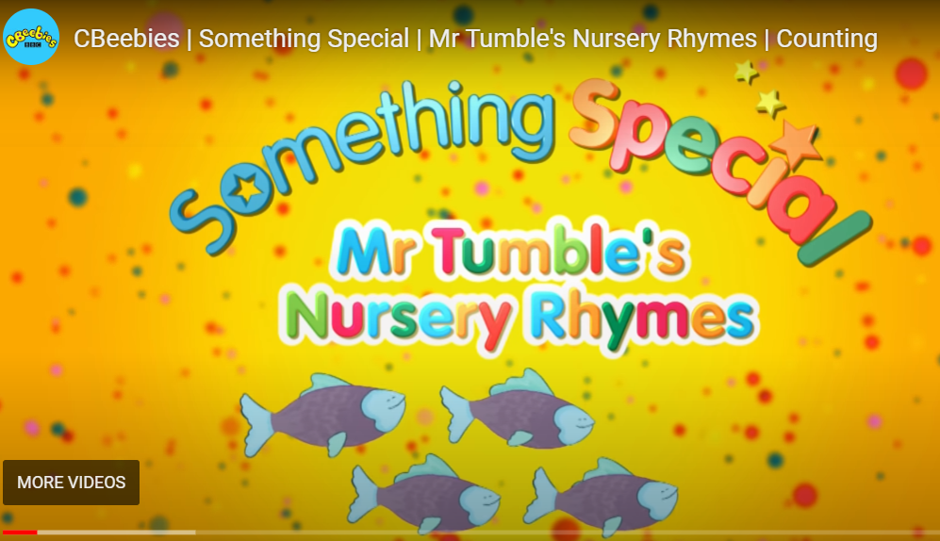 | Literacy Skill: Listening Skills  Activity:  Red Light, Green Light  This game is great for listening skills and to get your child moving.  How to play:  You can play the game indoors or outdoors. Take turns to move e.g dance, by saying “Go!”, and then say “Stop!” to freeze. If you’re child’s listening skills are more advanced give directions such as “jump up and down until I say stop”
Home Learning Topic Task
Find as many things in your house that tell the time. Which room are they in? How many can you find?
Why do we need to know the time? 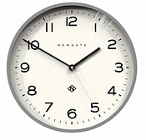
Cornflour Gloop
A great activity for in the kitchen or a well-covered dining table or floor.
Children love to explore cornflour both dry (beware, it is messy), and mixed with water ( a little at a time). Encourage them to explore the texture. Talk about what happens… can they squash it together, make shapes, draw patterns.

You can use ICT devices, phones, tablets, iPads, paper, pencil etc to complete the tasks. Spread out the activities over the week. Please note you can be creative with this task in order to present

Thank you for completing the School Closure Home Learning Task Sheet – You support is very much appreciated.
Please return this sheet to your child’s class teacher on return to school. Diolch yn fawr!

