Name: L Hill Class: Nursery WK Beginning: 24.1.22

School Closure Home Learning Task Sheet: Expectations – 1 Maths Task + 1 Literacy Task Each Day and 1 Topic Task per week.
This task overview sheet is designed to be used by parents and pupils in the event of a school closure.
Tasks and activities do not need to be completed in the order that they are written.
Visit the school website and your child’s class page to view this sheet and any hyperlinks electronically.
Remember to post your activities onto Class Dojo…
Maths Skill: Number  Activity: All about Number 2  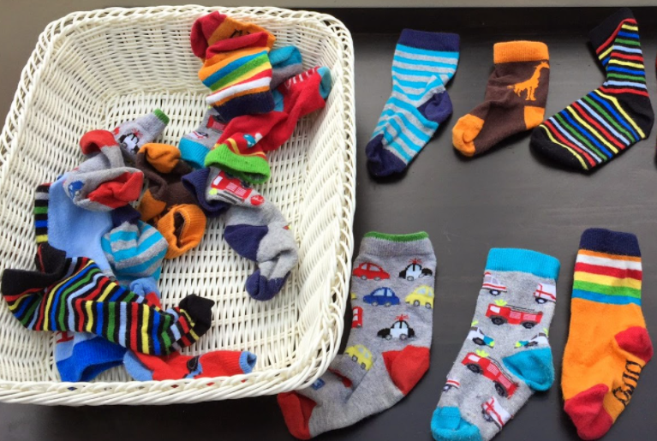  Find objects that come in pairs, such as socks, shoes, gloves. Muddle them all up. Children match the pairs, counting 1,2, as they go.  TF Write 1,2 | Literacy Skill: Oracy Activity: Singing about Feelings  Sing this song and do some actions to match… CT  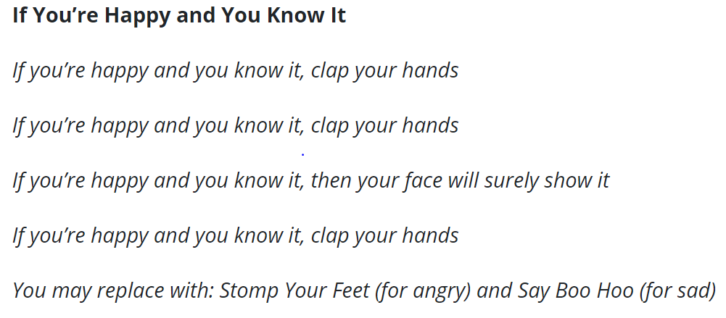  What other feelings can you think of?
Maths Skill: Number  Make writing Number 2 fun!  Use some of the ways we’ve tried before…  - Sky write with a finger, a wand  - Use shaving foam or gloop  - Condensation of glass  - In a tray of dried pulses, rice…  What ways can you think of? CP  Activity:  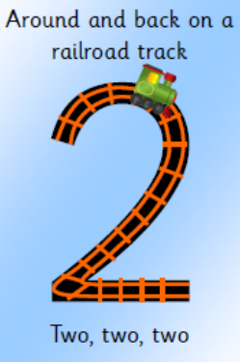 | Literacy Skill: Reading Activity: Talking about how we feel about a story  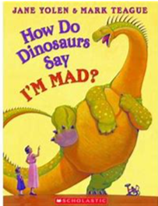  Share favourite stories this week.  Encourage your child to talk about it and to give their opinions.  What do they like about it? What is the best bit?  What bit is not so good?  What character would they like to be?  Can they give you a reason for their choices?  CT
Maths Skill: Number Activity: Learn a Number rhyme…  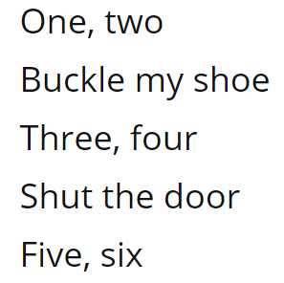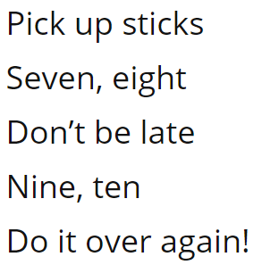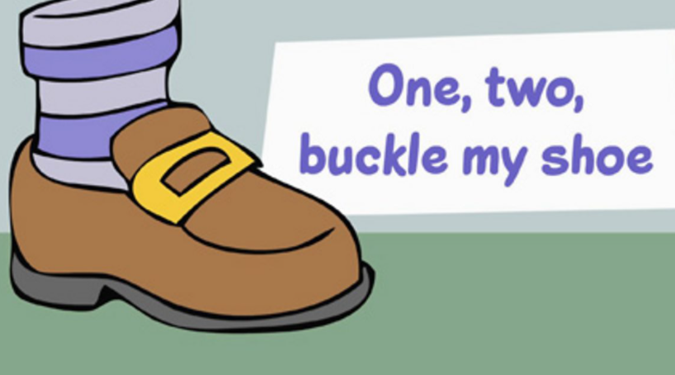 | Literacy Skill: Listening Skills Activity: Lost “Teddy”  Play a game to encourage careful listening.  Pretend Teddy is lost in the jungle. The child hides their eyes (or goes outside the room), while a teddy bear is hidden somewhere in the room. When they return, you guide the rescuer to the teddy by singing louder as the rescuer gets closer to, or quietly as the rescuer moves further away from the teddy.
Maths Skill: Shape Activity: Looking for circles.  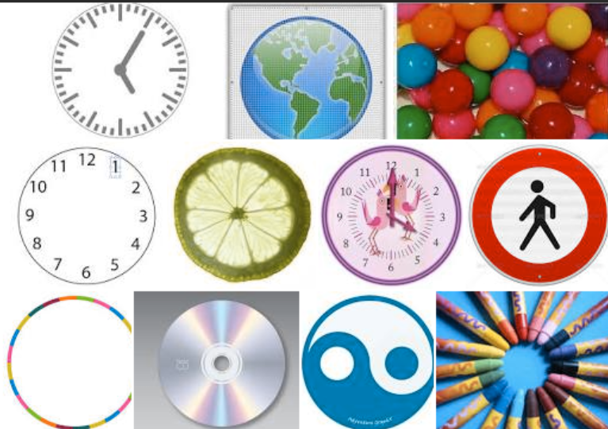  What is a circle? Draw the shape in the sky.  There are plenty of songs on Youtube about 2D shapes to sing along to.  Find as many circles in and out of your house as you can.  What circle pictures can you draw?  TF – make moons | Literacy Skill: Mark-making Activity: Patterns  Use a variety of crayons, paint, pens, gloop, pulses and sky writing to make patterns. Try 1 pattern at a time.  These encourage improved fine motor control in readiness for letter formation.  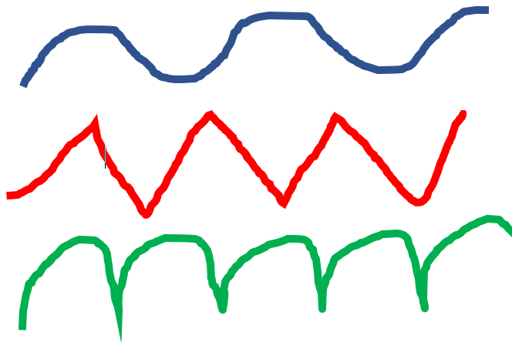  TF paint patterns on table
Maths Skill: Representing Numbers Activity: Showing how many by drawing 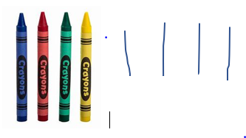 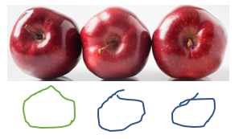  Try this important number activity. It will help careful counting.  Make a small collection of items, (no more than 5 to start) and encourage your child to show how many objects there are by drawing shapes or lines. TF | Literacy Skill: Oracy Activity: I feel …..when….  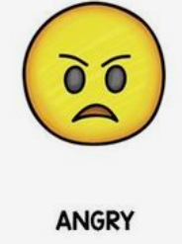  Pick times during the day to talk about feelings. Maybe during an activity, a TV programme, at storytime or when playing with their toys.  Grown ups get involved too.  e.g. I feel happy when I ride my bike  I felt sad when my favourite mug broke. CT Welsh – Sut wyt ti
Home Learning Topic Task
Did anyone have games for Christmas?
Play a game that encourages taking turn-taking e.g. snap, Hungry Hippos, Elefun
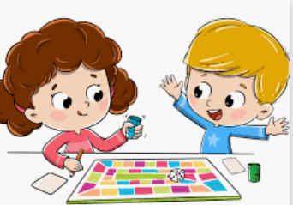

Have some fun!

Dance Party
Put on their favourite music and dance, dance, dance.

If you had a Magic Dream Wand what would you turn into? Create a picture or a model.
Use anything like…
You could use paint, crayons, pencils, playdough, recycled junk, lego. TF - oracy
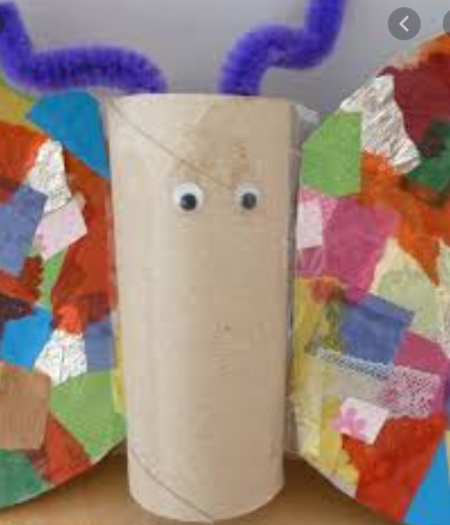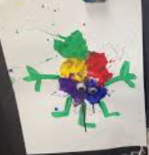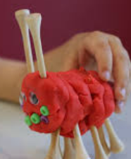

You can use ICT devices, phones, tablets, iPads, paper, pencil etc to complete the tasks. Spread out the activities over the week. Please note you can be creative with this task in order to present

Thank you for completing the School Closure Home Learning Task Sheet – You support is very much appreciated.
Please return this sheet to your child’s class teacher on return to school. Diolch yn fawr!

