
Name: L Hill Class: Nursery Week: 5
School Closure Home Learning Task Sheet: Expectations – 1 Maths Task + 1 Literacy Task Each Day and 1 Topic Task per week.
This task overview sheet is designed to be used by parents and pupils in the event of a school closure.
Tasks and activities do not need to be completed in the order that they are written.
Visit the school website and your child’s class page to view this sheet and any hyperlinks electronically.
Remember to post your pictures and photos on our Class Dojo this week…
Maths Skill: Recite numbers from 0 to 10 forwards and backwards using songs Activity: Sing a counting song  Counting 1-10 - BBC Bitesize - Bing video  There are plenty of fun songs and rhymes on BBC bitesize.  Choose one and practice counting forwards and backwards from 1-10.  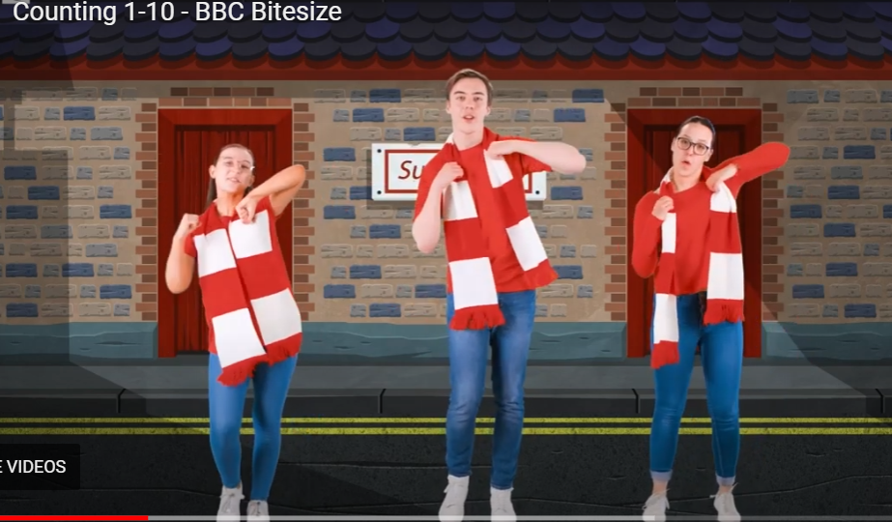 | Literacy Skill: Reading Activity: Enjoying a story together  Try to share a story at least once a day.  It could be from their favourite picture book, an ebook or one of the many stories that can be found online.  Dojo points are given each time you post a picture of you reading.    Use your Oxford Owl link
Maths Skill: Number Activity: All about Number 3  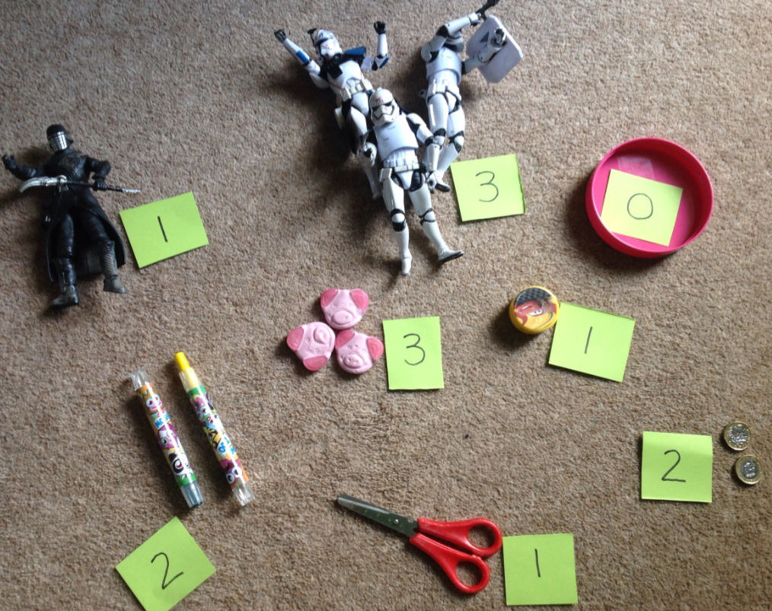  Make sets of objects from 0-3, encouraging the children to count along and match a numeral. | Literacy Skill: Oracy Activity: Talking about how I feel  Some of you made faces on circles last week. So, you could use those. Or make new ones like these.  Use a sentence starter & take turns e.g. I feel happy when… I splash in puddles.  Act it out, get silly and have fun.  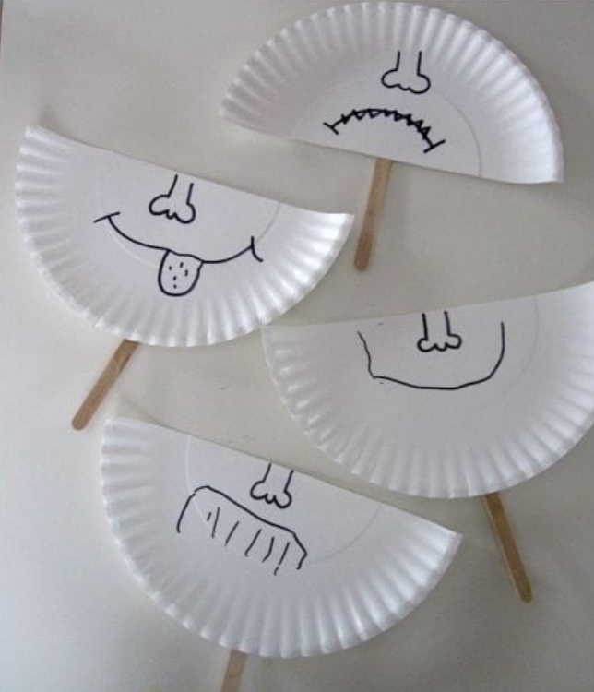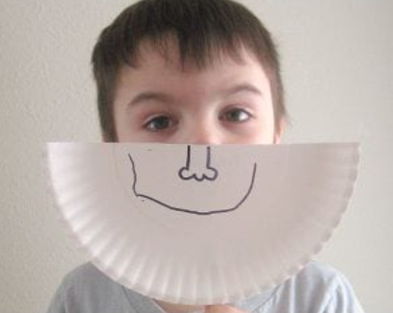
Maths Skill: Number Activity: Writing 3  Make writing Number 3 fun!  Use some of the ways we’ve tried before…  - Sky write with a finger, a wand  - Use shaving foam or gloop  - Condensation of glass  - In a tray of dried pulses, rice…  What ways can you think of?  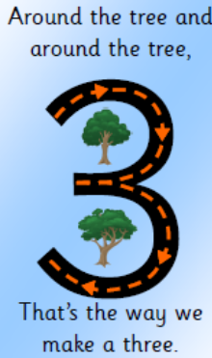 | Literacy Skill: Following instructions Activity: Make a face  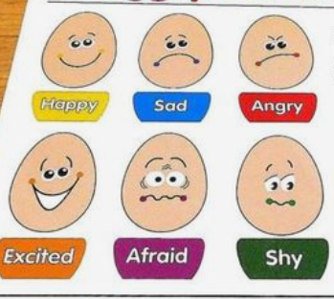  Find online or draw simple faces (as shown), on separate pieces of paper. Play some games e.g. Take turns to show a picture and pull that face or Make a face and the other person has to guess how you are feeling.
Maths Skill: Shapes Activity: Finding squares  What is a square?  A square has 4 straight sides all the same size and 4 corners.  Draw the shape in the sky.  Again, on Youtube, you will find songs about 2D shapes to sing along to.  Cut 4 strips from paper, card, lengths of wool.  Can your child make a square?  What square shapes can you find when you go outside?  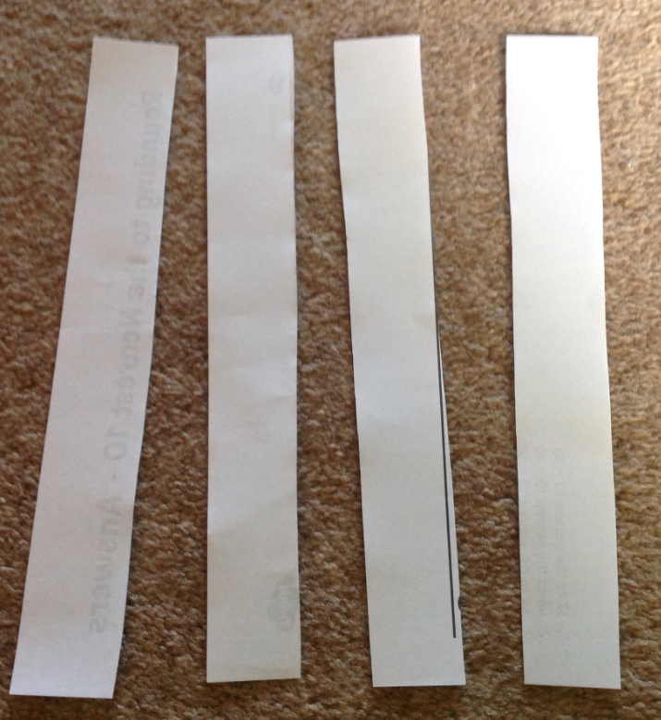  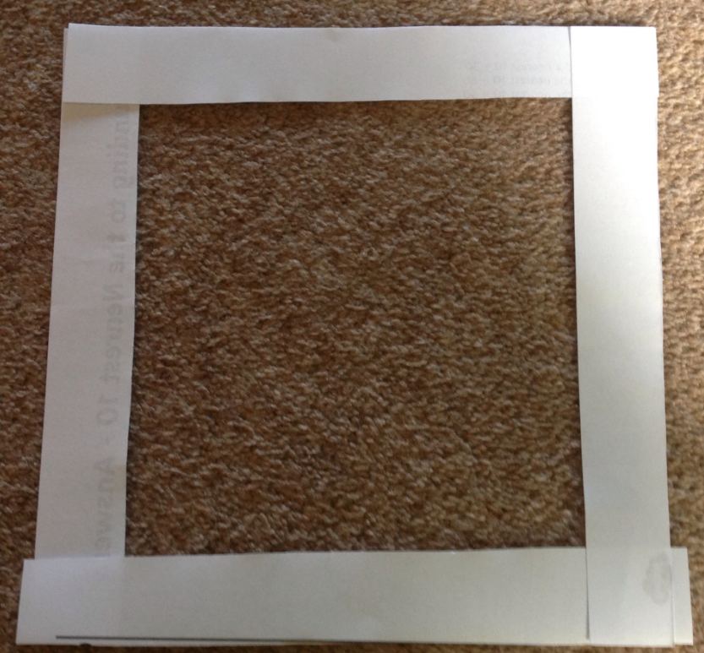 | Literacy Skill: Writing Activity: Making patterns  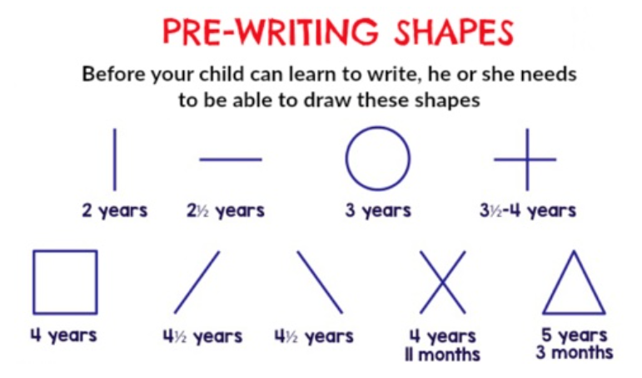  It is important for young children to get lots of practice developing pre-writing skills. We don’t make them write letters before they are ready.  You can help them to develop these skills by letting them have fun, simply making patterns (as shown)  Use anything you can get hold of e.g. crayons, pens, dried pulses, foam, gloop, paint…
Maths Skill: 1-to-1 correspondence i.e. Giving a correct number name to an object as they are counted in order Activity:    Lots of different activities at home can help develop this skill…  Making cakes & placing a sweet on each one  Playing with a tea-set and matching cups & saucers  Putting on socks, shoes & gloves (learning about 2 in a pair)  Climbing the stairs | Literacy Skill: Reading Activity: I know my name.  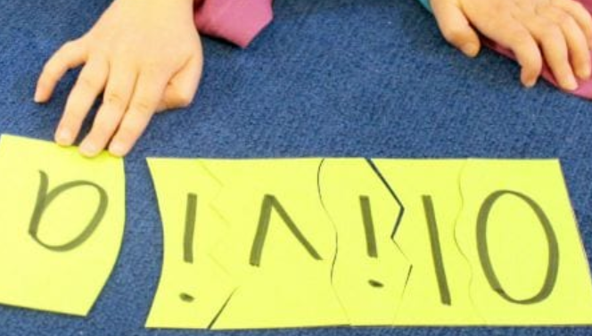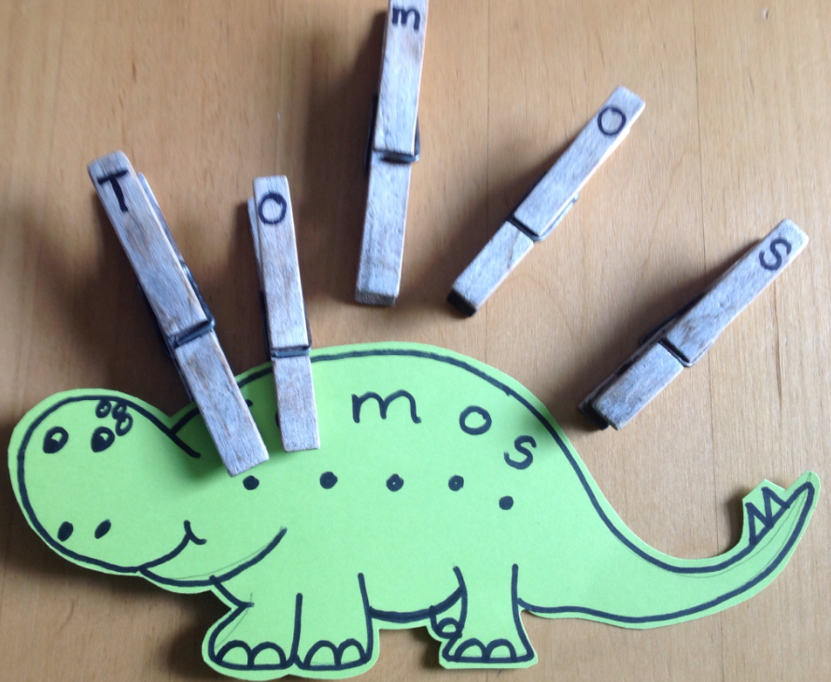  Children need to know what their name looks like. You can help your child to learn to recognise their name. Here are two ideas.  In school, we use a Capital letter to start a name and the others are small letters.
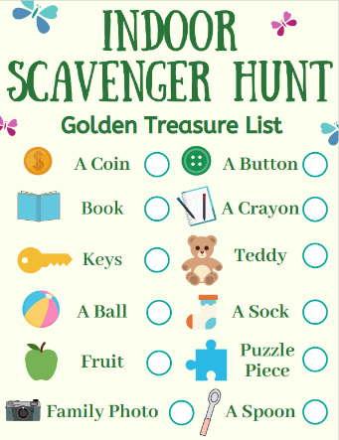
Home Learning Topic Task
To burn off some energy and get children using their eyes, try a Scavenger Hunt, like this one. You could make your own…
Post a photo of what they found on our Class Dojo.
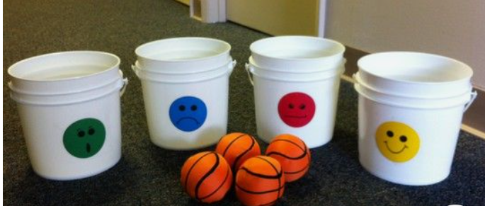
You don’t need buckets & balls. You could use balled up socks to throw and tray/paper as targets.

You can use ICT devices, phones, tablets, iPads, paper, pencil etc to complete the tasks. Spread out the activities over the week. Please note you can be creative with this task in order to present

Thank you for completing the School Closure Home Learning Task Sheet – You support is very much appreciated.
Please return this sheet to your child’s class teacher on return to school. Diolch yn fawr!

