Name: Year: 3 Week: 2


School Closure Home Learning Task Sheet: Expectations – 1 Maths Task + 1 Literacy Task Each Day and 1 Topic Task per week.

This task overview sheet is designed to be used by parents and pupils in the event of a school closure.
Tasks and activities do not need to be completed in the order that they are written.
Visit the school website and your child’s year group page to view this sheet and any hyperlinks electronically.
Maths Skill: Odd and Even Numbers x10  Activity: Recap what odd numbers are and what even number are. Numbers ending in 2,4,6,8,0 are even and numbers eding in 1,3,5,7,9 are odd.  Group 1 - Write down a number, children decide if it is odd or even.  Group 2 - Choose random numbers to sort odd and even numbers using the venn diagram. You can think of your own titles if you like.  Numbers above 50 Odd Numbers  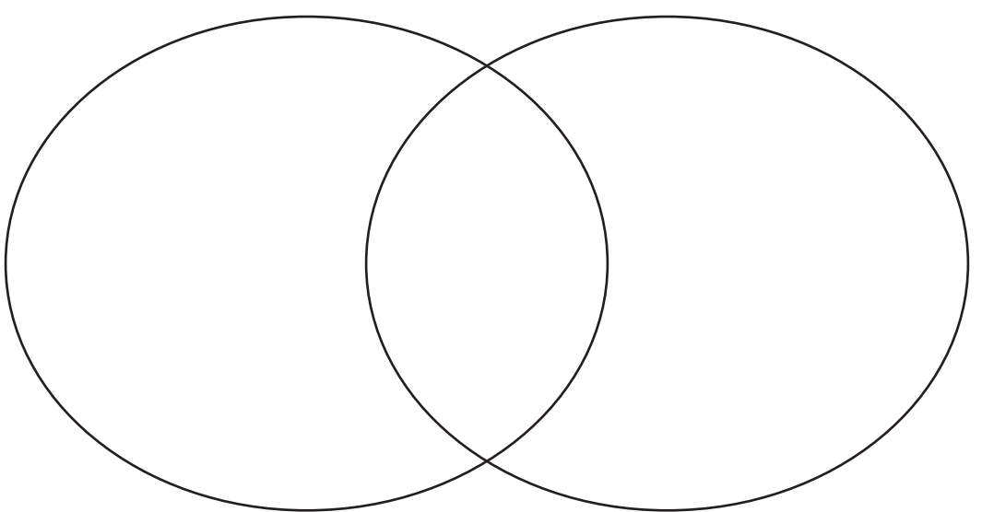  Group 3 - Workout is the statements are true or false E.g. you may need to try different sums to check your answers.  Odd+Odd= Even? Odd+Even=Even? Even+Even=Odd? Even+Odd=Odd?  Date completed ……………………………….. | Literacy Skill: write for different purposes and readers choosing words for variety and interest  Activity: To write a letter to the local council to persuade them to build your garden that you designed in week 1. Start by planning what you are going to write  - Write down reasons why your garden should be built.  - Try and use persuasive sentence openers e.g.  It is important that….  - Others agree that…  - Without a doubt…  - I feel extremely confident that….  - I am absolutely certain that….  Date completed ………………………………..
Maths Skill: Use written strategies to Add numbers. X10  Activity: Add numbers together using the column method. Remember to write the biggest number on the top. E.g. 53+ 43+ 545+  5 36 58  __ __ ___  Group 1 - Add 2 digit by 1 digit numbers.  Group 2 - Add 2 digit by 2 digit numbers.  Group 3 - Add 3 digit by 2 digit numbers. Challenge - Try sums that need to carry over.  Date completed ……………………………….. | Literacy Skill: write for different purposes and readers choosing words for variety and interest  Activity: To begin to write your letter to persuade the council to build your garden.  Remember-  - Write your address.  - Write the address of who you are  writing to (the recipient’s address).  - Write a greeting (the recipient’s name).  - Write the full date.  Introduce the topic you are writing about and state the argument– do you agree or disagree? Why?  Date completed ………………………………..
Maths Skill: Use written strategies to Subtract numbers. X10  Activity: Subtract numbers together using the column method. Remember to write the biggest number on the top. E.g 55- 46- 545-  3 33 58  __ __ ___  Group 1 - Subtract 2 digit from 1 digit numbers.  Group 2 - Subtract 2 digit from 2 digit numbers.  Group 3 - Subtract 2 digit from 3 digit numbers. Challenge - Try sums that need to borrow from the next collum.  Date completed ……………………………….. | Literacy Skill: write for different purposes and readers choosing words for variety and interest  Activity: To write your letter to persuade the council to build your garden.  - Explain in detail, using words such as: Firstly… Secondly… In my opinion… Some believe that… I feel that… I am sure that…  - Describe, using great adjectives.  - Argue why it is so good or bad – be enthusiastic!  - Use powerful verbs.  - Give reasons for and against – use evidence.  Date completed ………………………………..
Maths Skill: Identify 2D Shapes X10  Activity: Draw and Label as many 2D shapes as you can. Then get an adult to check them and go through any shapes you may have missed. Use a ruler if you have one to practice drawing straight lines where needed.  Group 1 - Square, Rectangle, Circle, Triangle  Group 2 - Square, Rectangle, Circle, Triangle, Pentagon, Hexagon.  Group 3 - Draw and lable as many as you can remember  Challenge - Can you describe the features of the shapes you have drawn. E.g. Number of sides and Vertices (Points)  Date completed ……………………………….. | Literacy Skill: write for different purposes and readers choosing words for variety and interest  Activity: To finish your letter to persuade the council to build your garden.  - Ask the recipient questions to get them thinking and make them realise they need this.  - There is a conclusion which summarises the main point of the letter and our opinion.  - End with a summary of what you need.  - The letter finishes with your faithfully if you do not know the name of the recipient or your sincerely if you do  Date completed ………………………………..
Maths Skill: Understand directions X10  Activity: Use directions North, South, East and West to get from one place to another (inside or outside the house) E.g. Living room to bedroom. Take it in turns to give or receive the instructions with a family member.  Group 1 - Use 4 point directions.  Group 2 - Use 8 Point Directions.N, NE, SE, S, SW, W, NW.  Group 3 - Use 8 Point Directions. N, NE, SE, S, SW, W, NW.  Challenge - Record the directions form one place to another.  Date completed ……………………………….. | Literacy Skill: review and improve sections of their work  Activity: Read through you work and check for:  - Have you used joined handwriting?  - Check your punctuation- full stops, capital letters, question marks and exclamation marks  - Can you use paragraphs?  - Have you checked your spelling of key words?  - Have you included any questions?  Date completed ………………………………..
Home Learning Topic Task
Design your own planet. On this planet you can create your own animals and plants.
Think of the colour/shape/name/size of the planet
Does it have water or something like water?
What animals have you got living on your planet? (use your imagination and get creative)
What plants have you got living on your planet? (use your imagination and get creative)
What habitats are on your planet?
Write about your planet
Create a tourist brochure
Create a poster advertising your planet

You can use ICT devices, phones, tablets, iPads, paper, pencil etc to complete the tasks. Spread out the activities over the week. Please note you can be creative with this task in order to present

Thank you for completing the School Closure Home Learning Task Sheet – You support is very much appreciated.
Please return this sheet to your child’s class teacher on return to school. Diolch yn fawr!

